**Assignment-16-May-2022:**

1. **What is a launch template?**

Launch Templates is a new capability that enables a new way to templatize your launch requests. Launch Templates streamline and simplify the launch process for Auto Scaling, Spot Fleet, Spot, and On-Demand instances

A launch template is an Amazon Elastic Compute Cloud (EC2) feature that reduces the number of steps that are required to create an AWS instance by capturing all launch parameters within one resource.

1. **Hands on- Create Launch Template ?**

**Go to EC2 and click on Launch Template.**

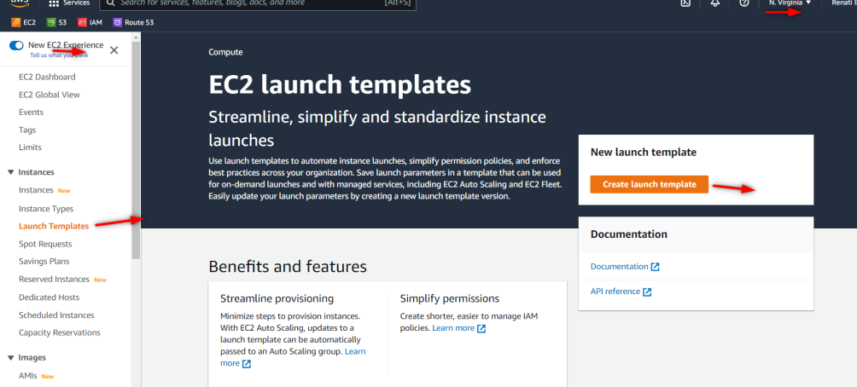

**Provide name, description and check the auto-scaling guidance.**

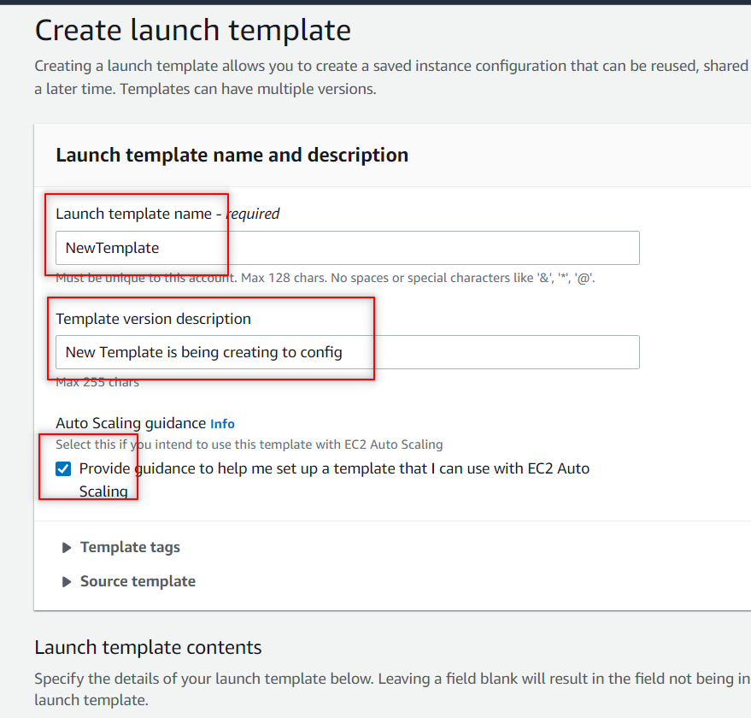

**Select the AMI from the recently launched and choose amazon2**

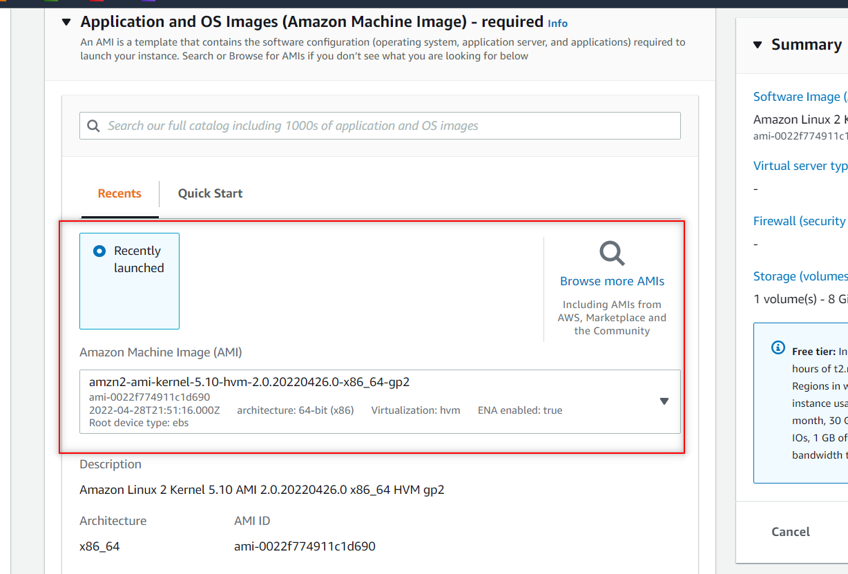

**Choose the instance type as t2 micro free one and kp.(and as well under network settings create one security group if not possible later u can do by opening the instance there go to security and there security grp link open there u can add the inbound rules as http, port 80).**

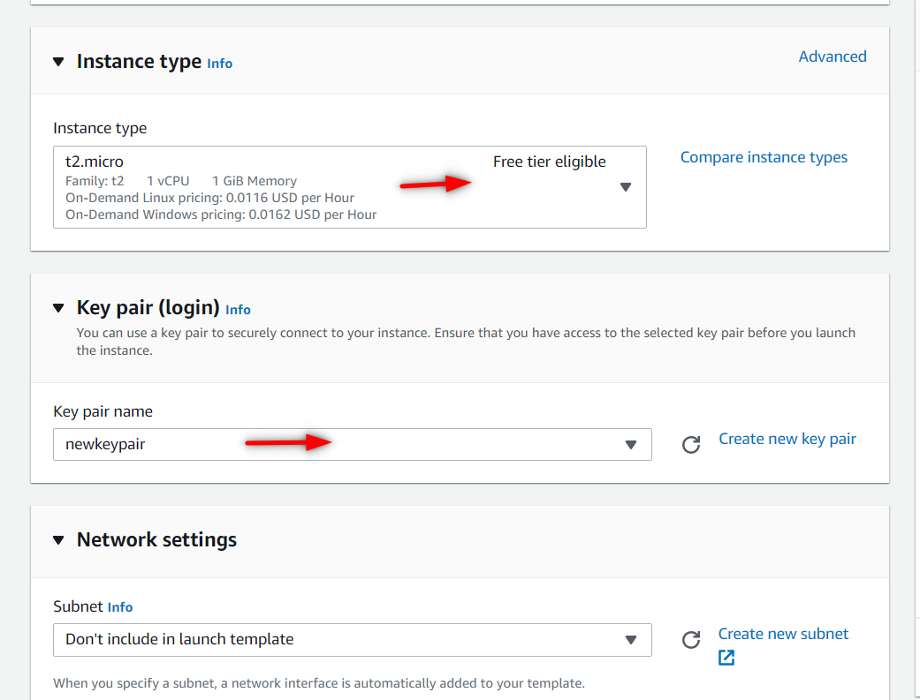

**Under Advance settings provide the user data**

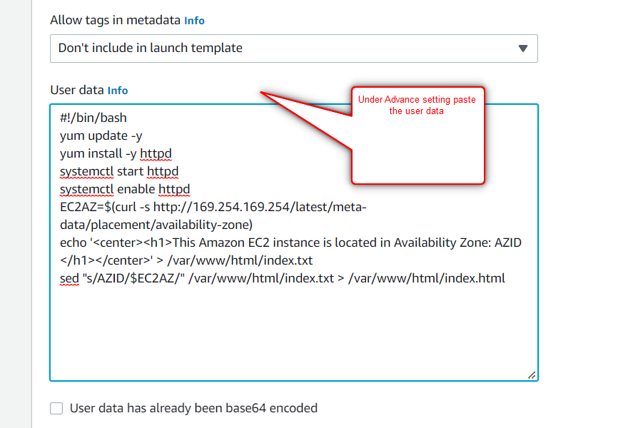

**Later click on create launch template.**

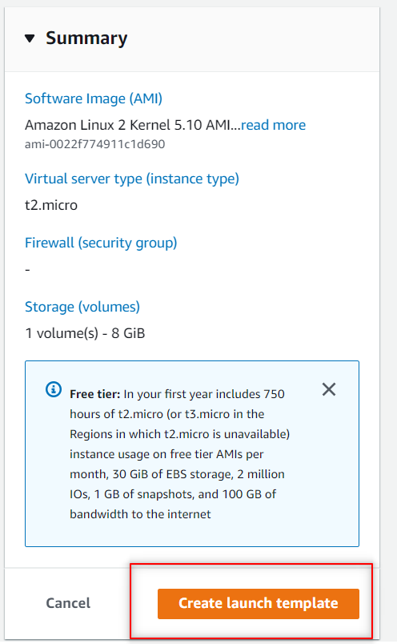

**Here u can see the template got created.**

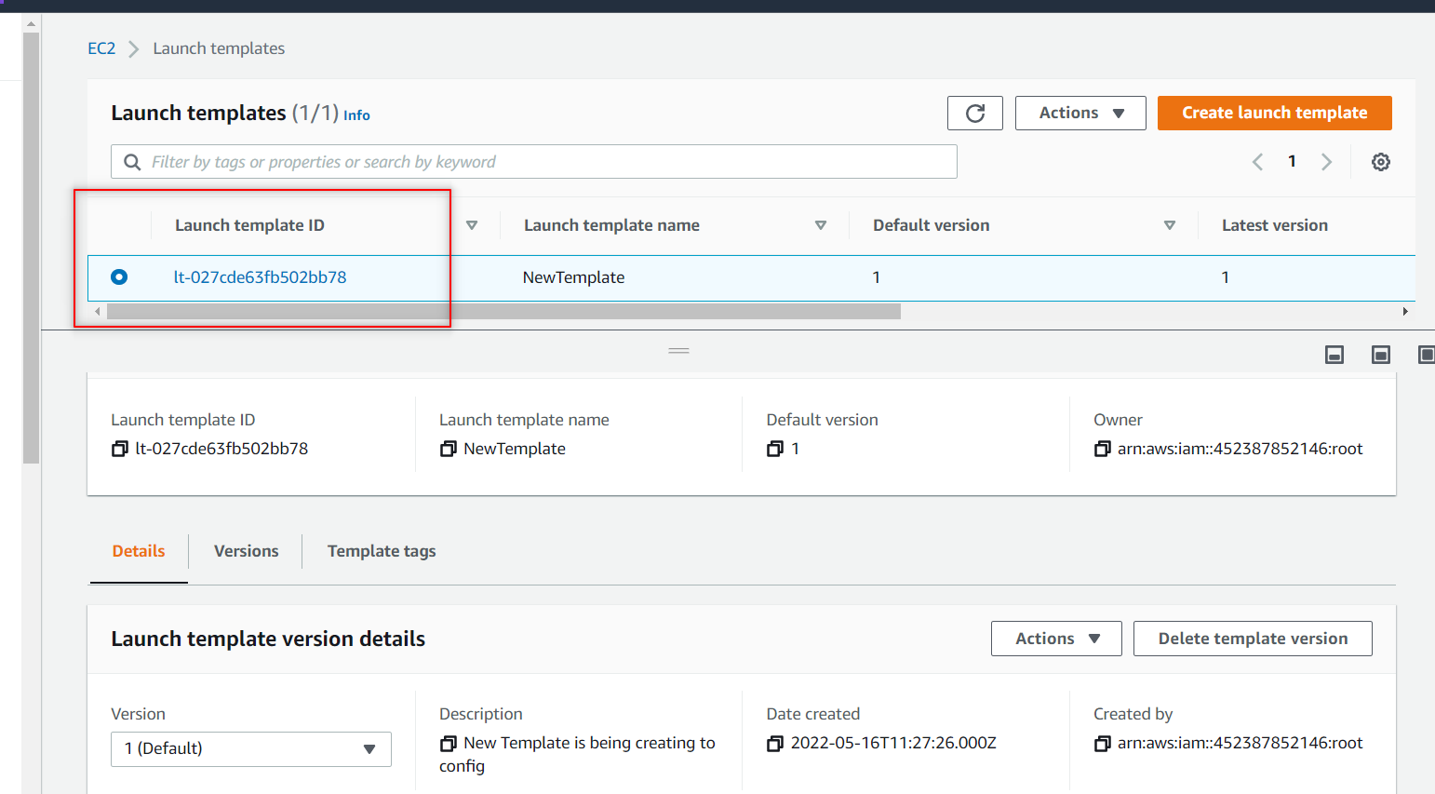

**++++++++++++++++++++++++++++++++++++++++++++++**

1. **Hands on – Create Auto Scaling Group ?**

**Go to EC2 and select the Auto scaling Group in the left side and click on create ASG.**

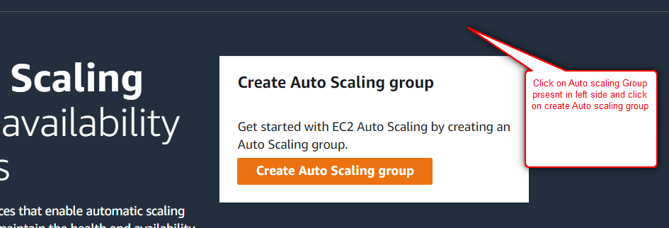

**Provide name, And choose the already created launch template and keep everything same as it is and click on next.**

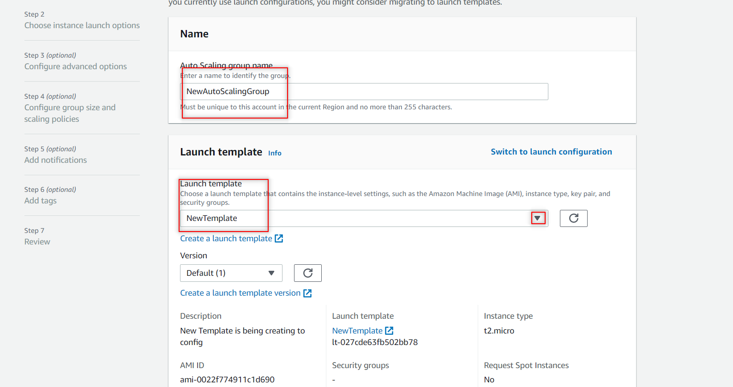

**In next step choose the all availability zones and click on next.**

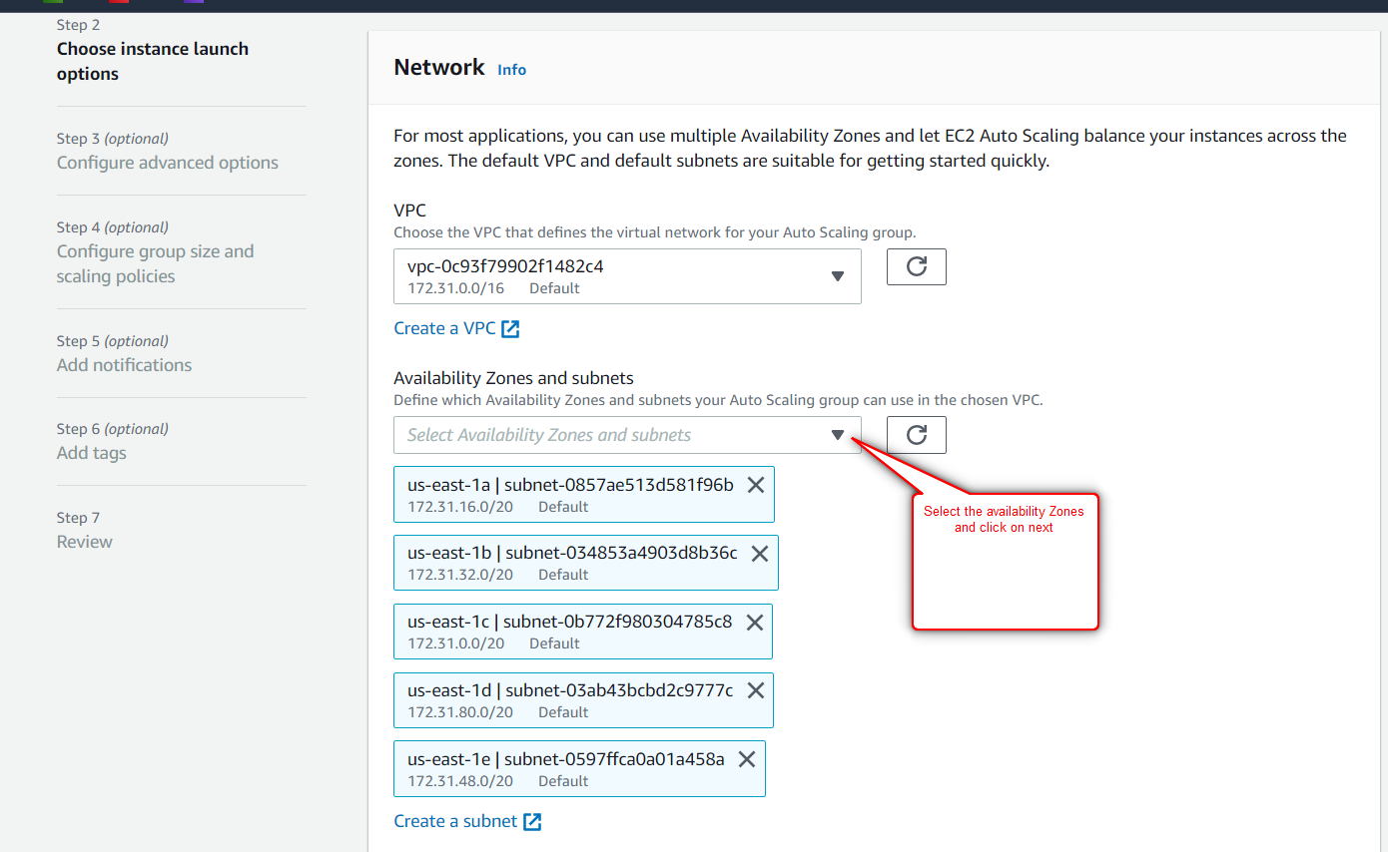

**Don’t change anything at step3 just click on next.**

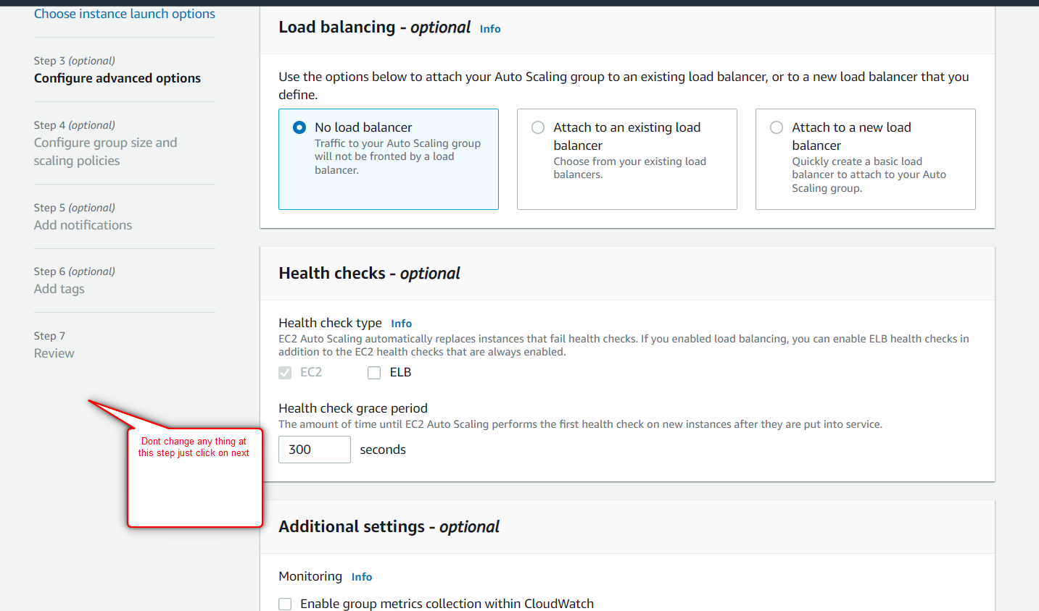

**In step4 choose the capacity as 2 or anything and click on next**

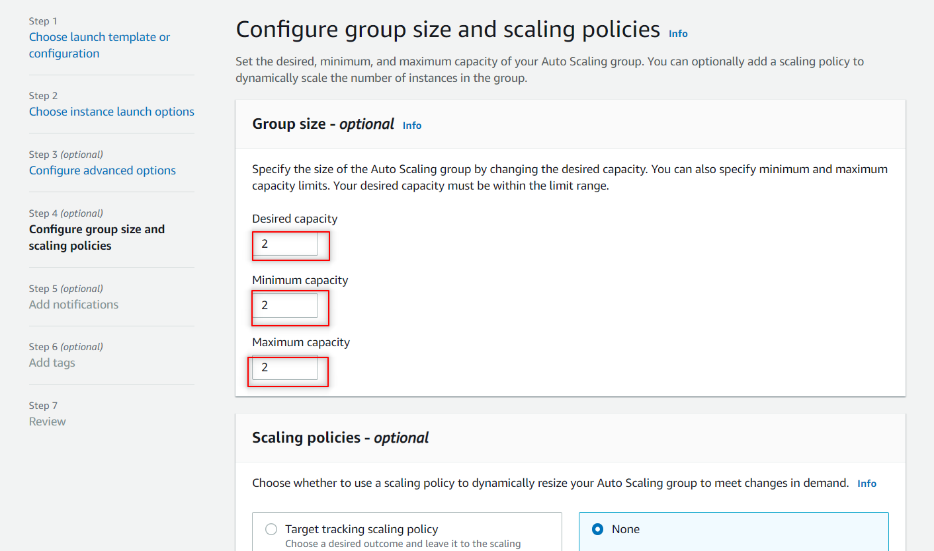

**Don’t make any changes in step 5,6 amnd in last step just check the reveiew and click on create Auto scaling group.**

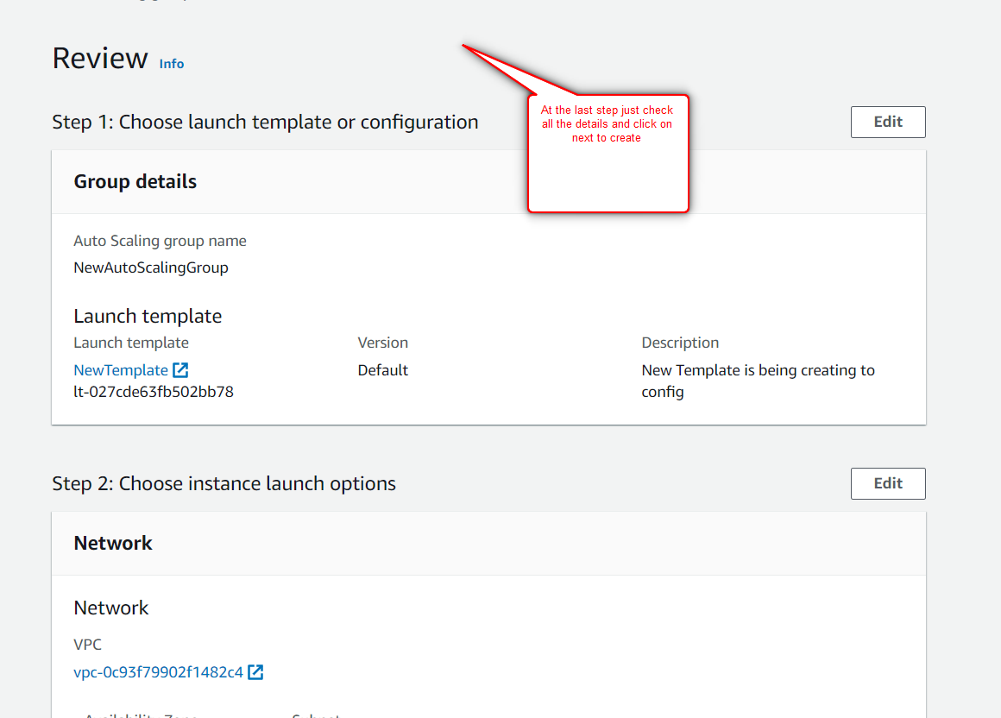

**Here u can see the created ASG.**

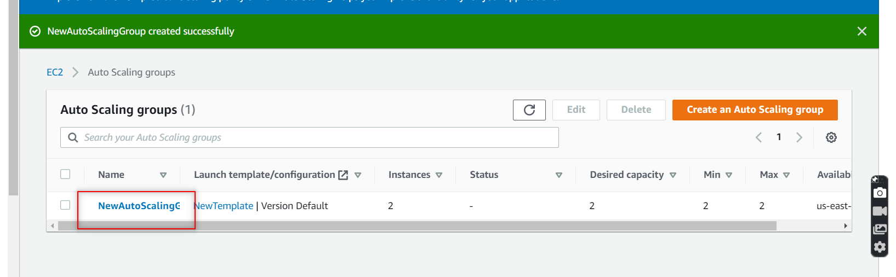

1. **Hands On – Create a Target group?**

**Go to EC2 and click on Target Group and there click on create TG.**

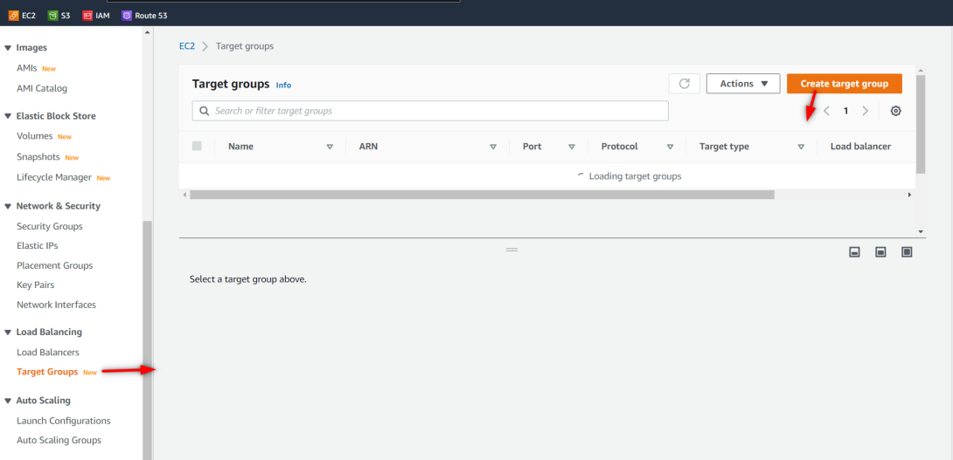

**Choose the target type as Instances and provide the Target-group name and check the port http-80 and click on next.**

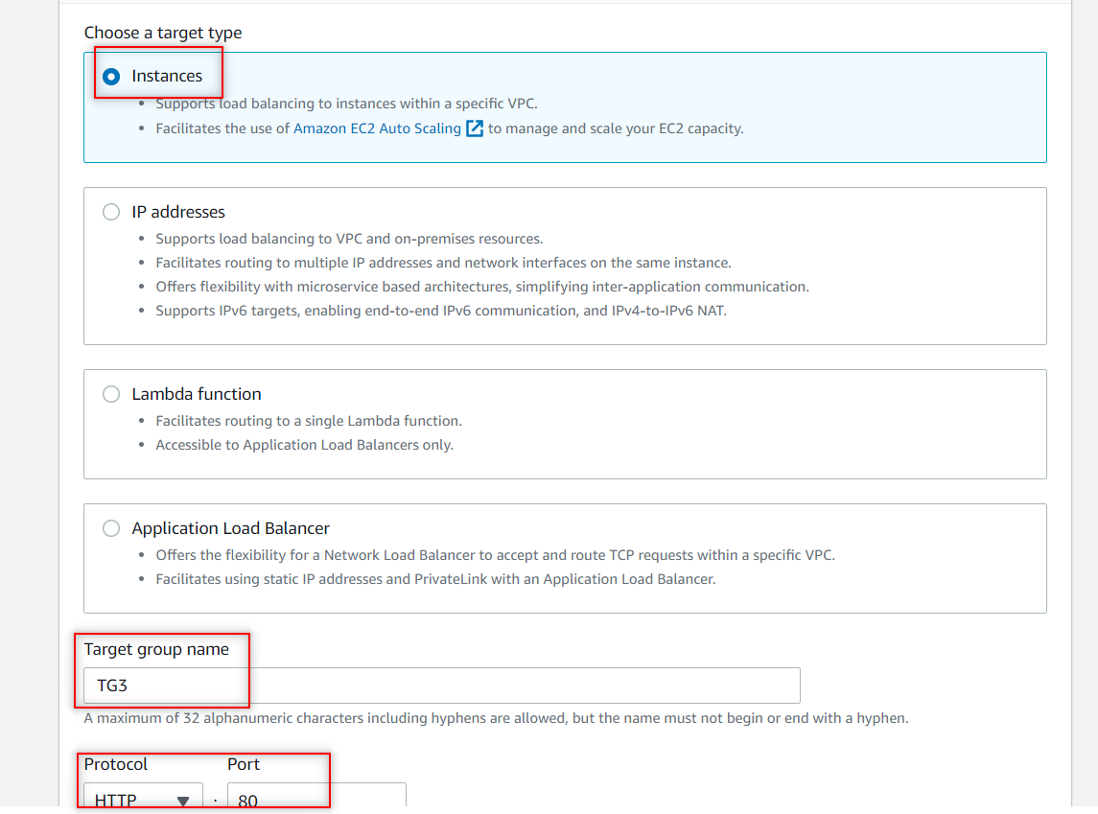

**Under step2 select the instances and click on Include as pending below button.as shown in pic.**

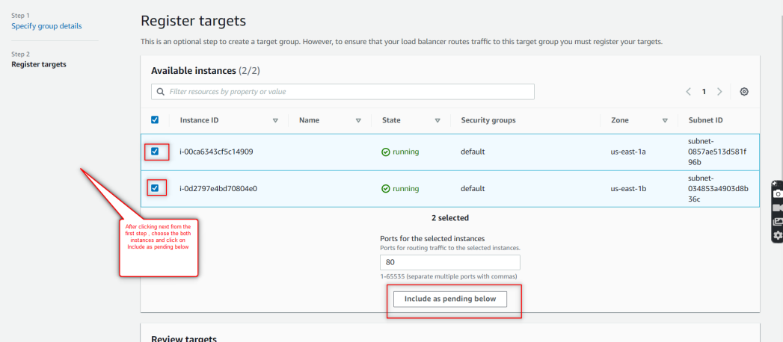

**Little bit down in the same page u can see the Health status as pending and click on create target group.**

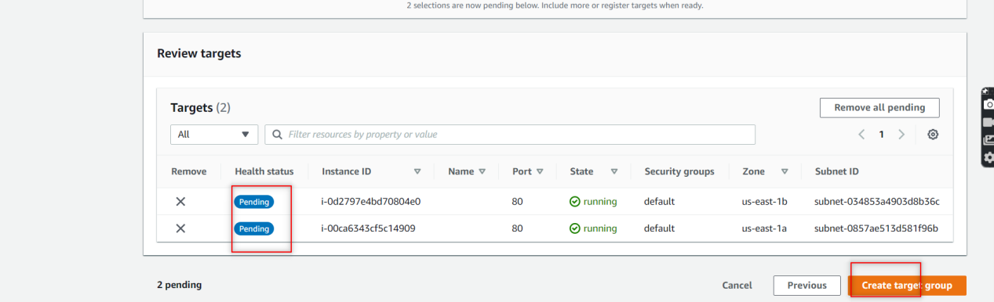

**Here the targeted group get created.**

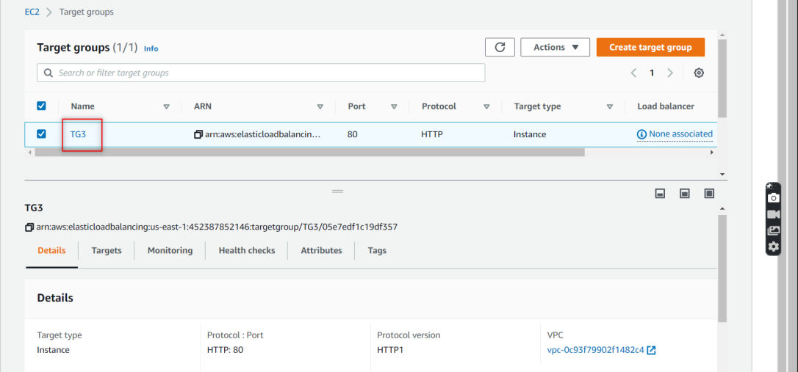

1. **Hands On – Create Load Balancer?**

**Go to EC2 and choose Load Balancer and click on create Load Balancer.**

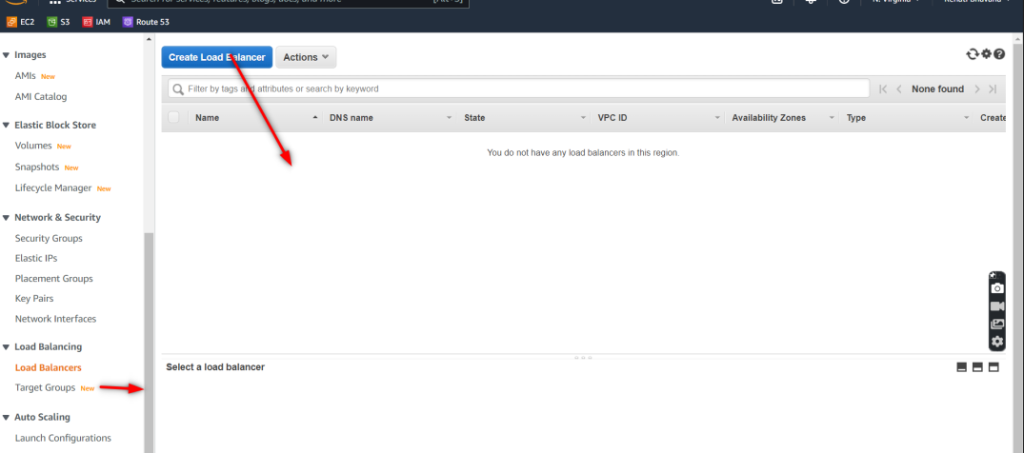

**Here select the Application Load Balancer and click on create.**

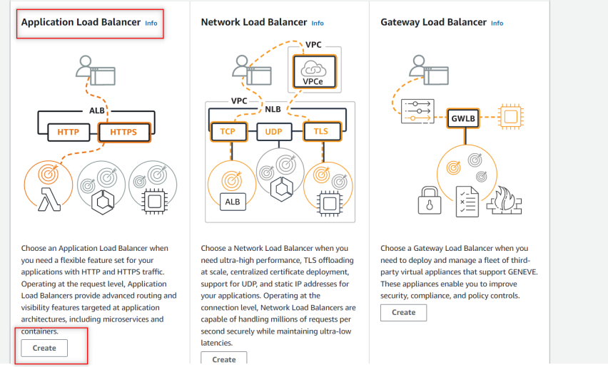

**Provide the LB Name and keep everything same.**

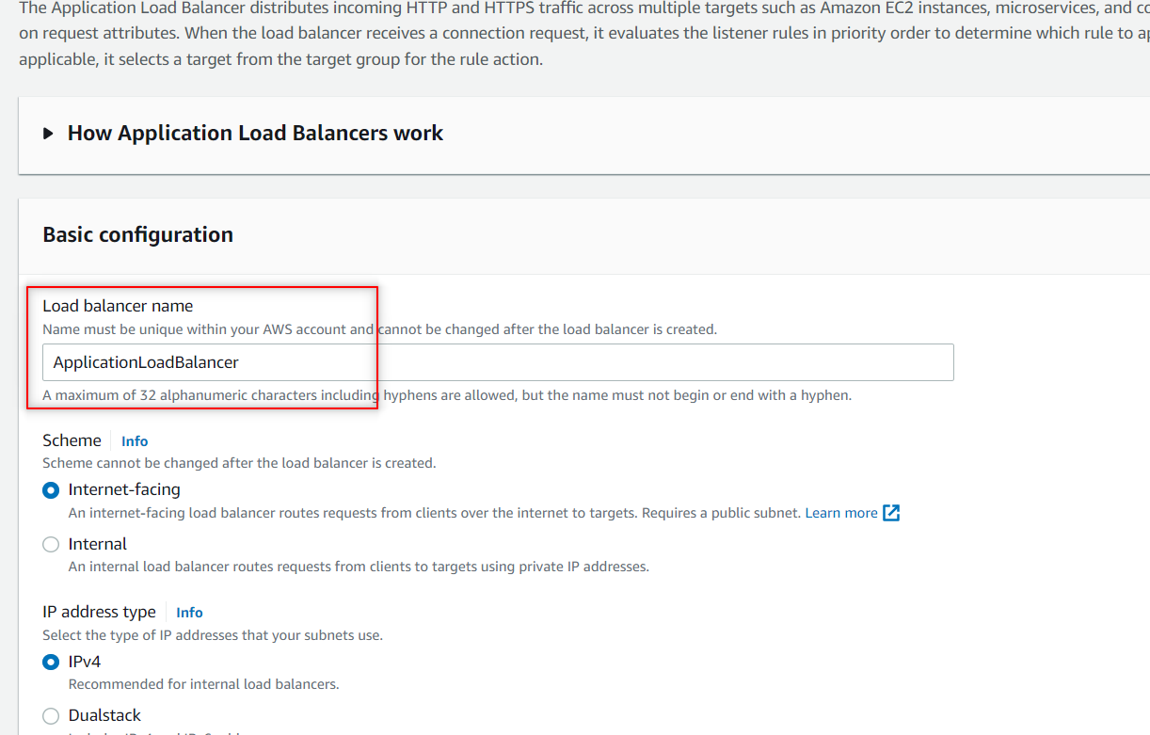

**Under Network mapping ,mapping--> check all the availability zones as shown in figure.**

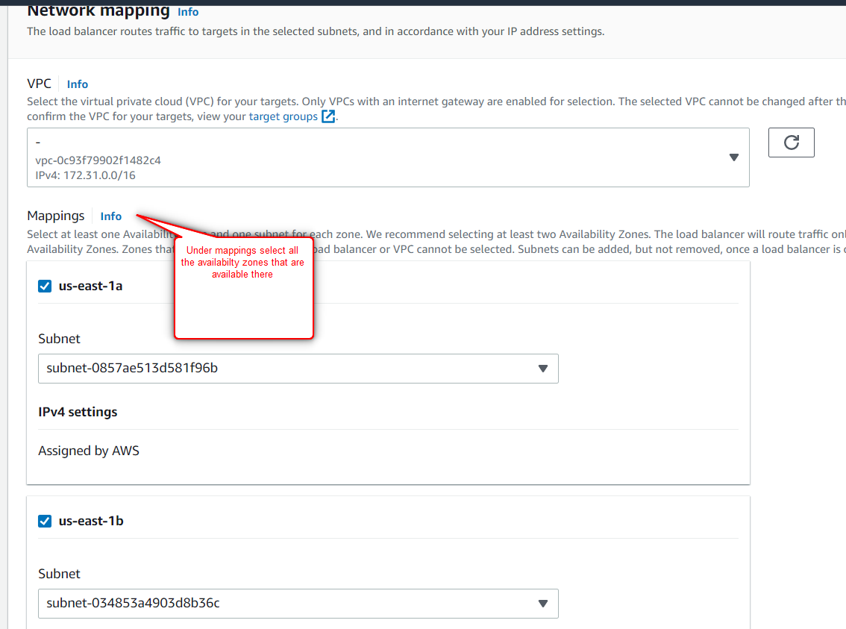

**Under Listeners and routing Choose the Default action as u created Target-Group name previously.and make sure Listener as HTTP-80.**

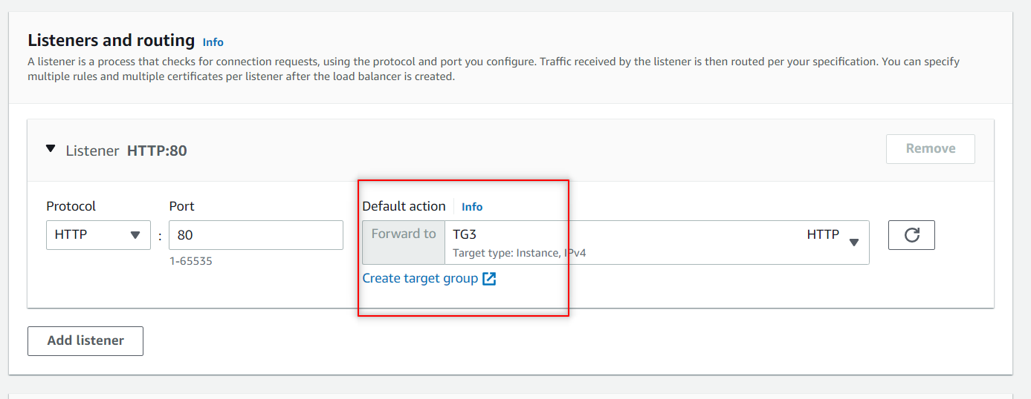

**And keep everything same and just click on create Load-balancer.**

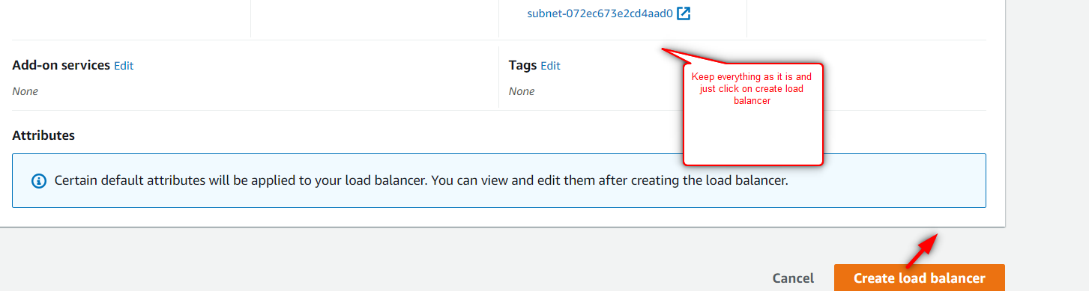

**Here u can see the created Load-balancer.**

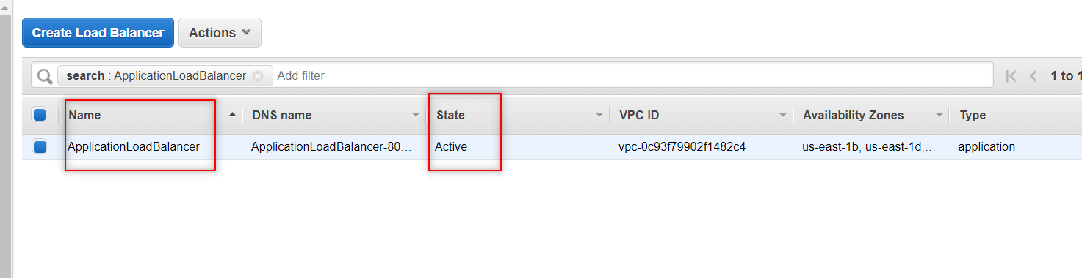

**Here in Auto-scaling-Group we will attach the Load-Balancer and Target-Group.**

**Now go to Auto-Scaling-Group , select the ASG that u created and Go to Details Tab->search for Load Balancing and there click on edit option.**

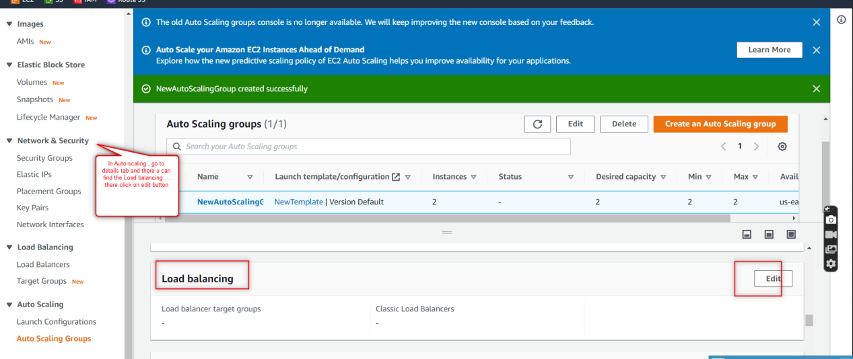

**After clicking on edit option ,select the 1st option(Application,Network/gateway Load-Balancer target groups) and there select the Target-Group name that u had created previously and click on update.**

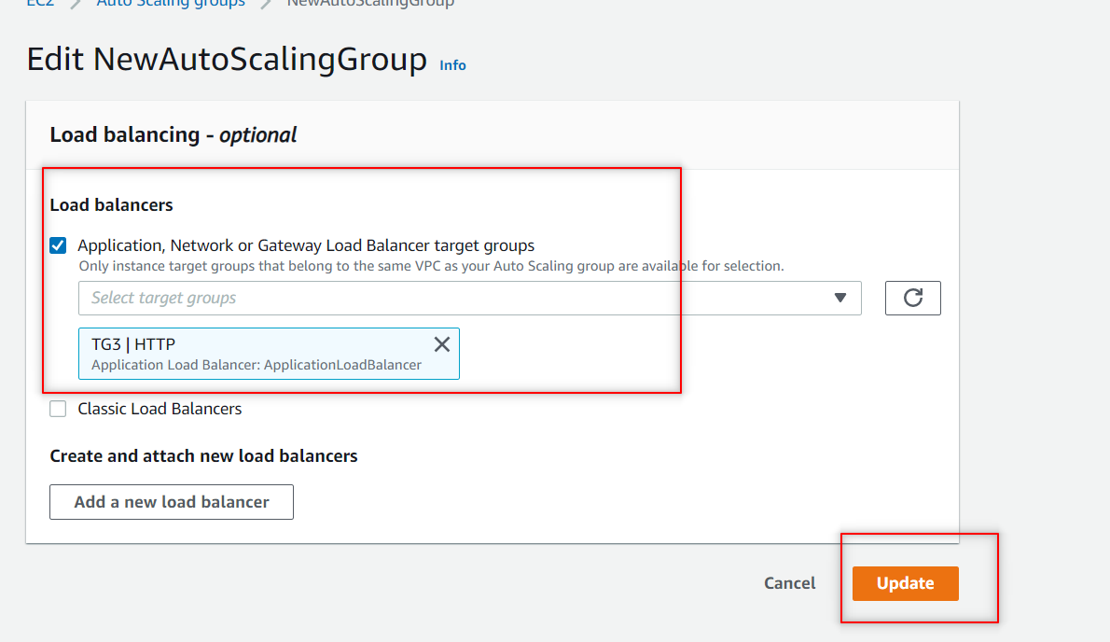

**In Auto-Scaling-Group-->Under Automatic scaling we will create a Dynamic Scaling policy**

**Now go to Auto-Scaling-Group , select the ASG that u created and Go to Automatic-Scaling and click on create Dynamic Scaling Policy.**

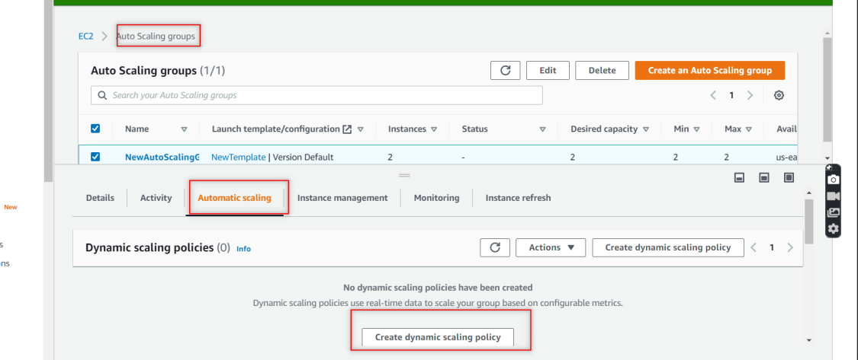

**Here under metric type -> choose Application Load Balancer request count per target. And Target-Group name that u had created previously and target value (something u can give 2,5,4,….) and click on create.**

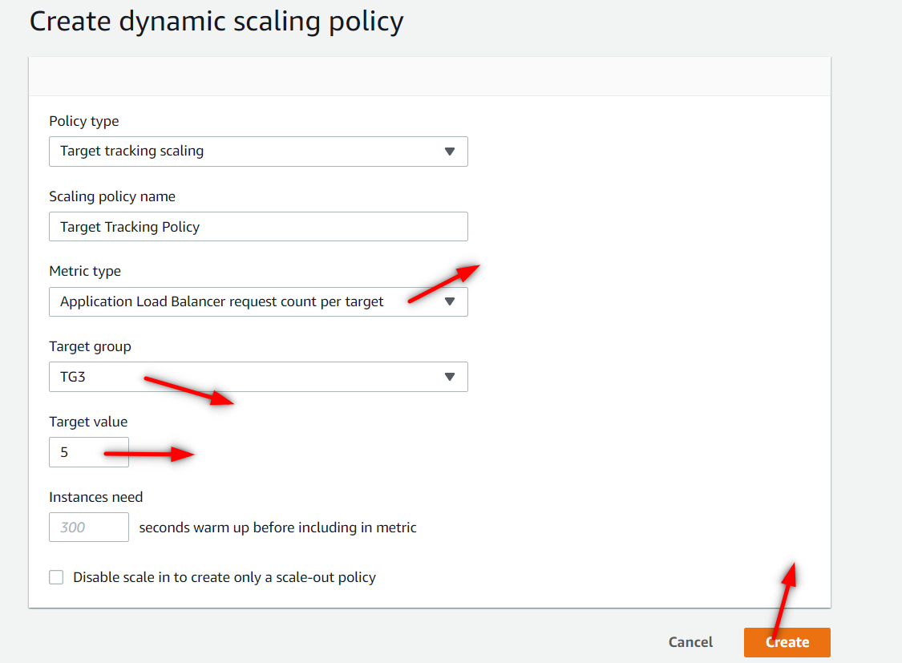

**Now Go to Load-Balancer , select the Load-Balancer that u created and under description tab u can find DNS Name , copy that URL and paste it in google u can see the data.**

